WEEKS WAVEMAKER INSTALLATION AND OPERATION

This documentation is intended as an informal user manual for researchers using the wave tank in the Weeks Hall freezer (room 254). Primarily documented by Anya Wolterman.

**WIRING 2**

**SAFETY 3**

**SOFTWARE 5**

Wavemaker start/stop 12

Wavemaker program generation 13

Spectra definitions 14

# WIRING

These wiring were installed and tested by Peter with EDL.

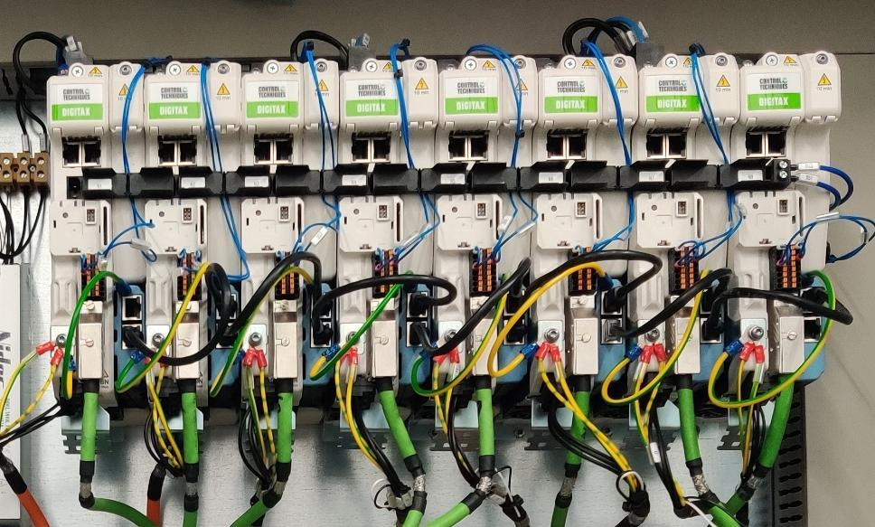

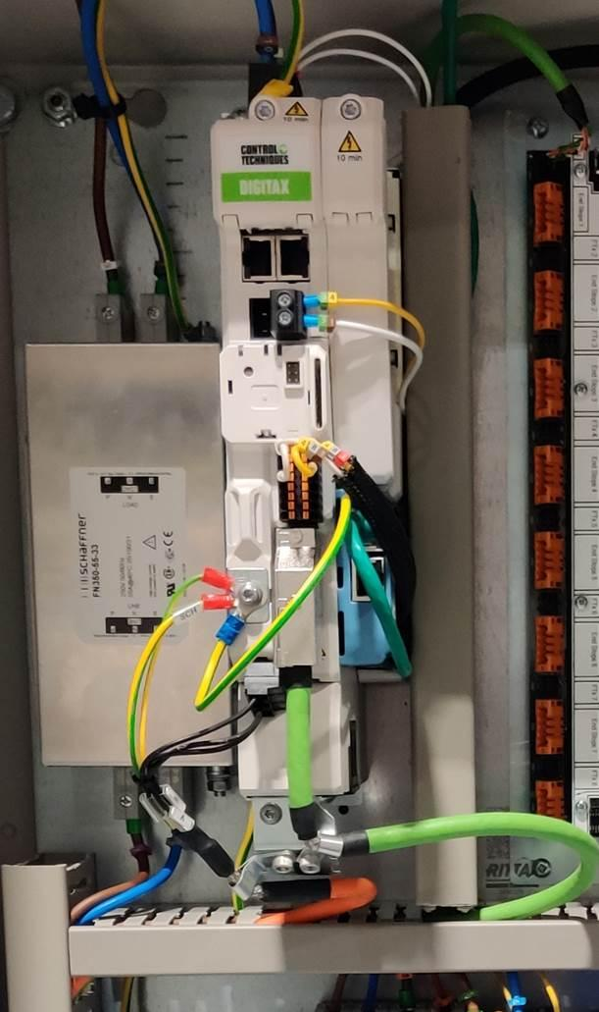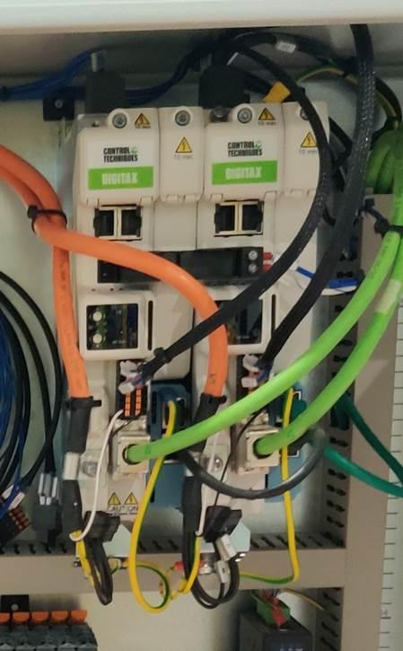

# SAFETY

The tank is grounded with a titanium rod in the back left corner, but regardless, remove all powered items before working in the tank.

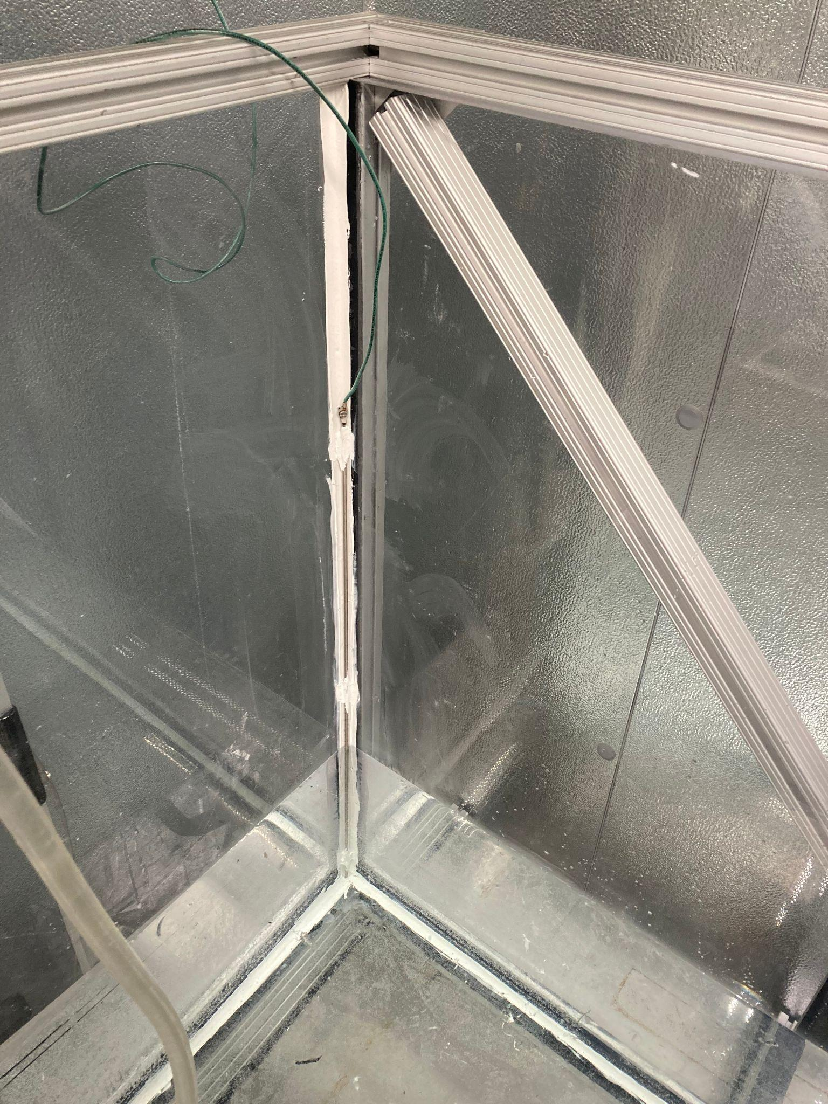

To kill power to the wave tank, turn the power switch on the cabinet to OFF (left) or hit the emergency machine stop button on the panel in the freezer (right) (but that is *just* for the wavemaker, not everything else that may be plugged into the tank):  
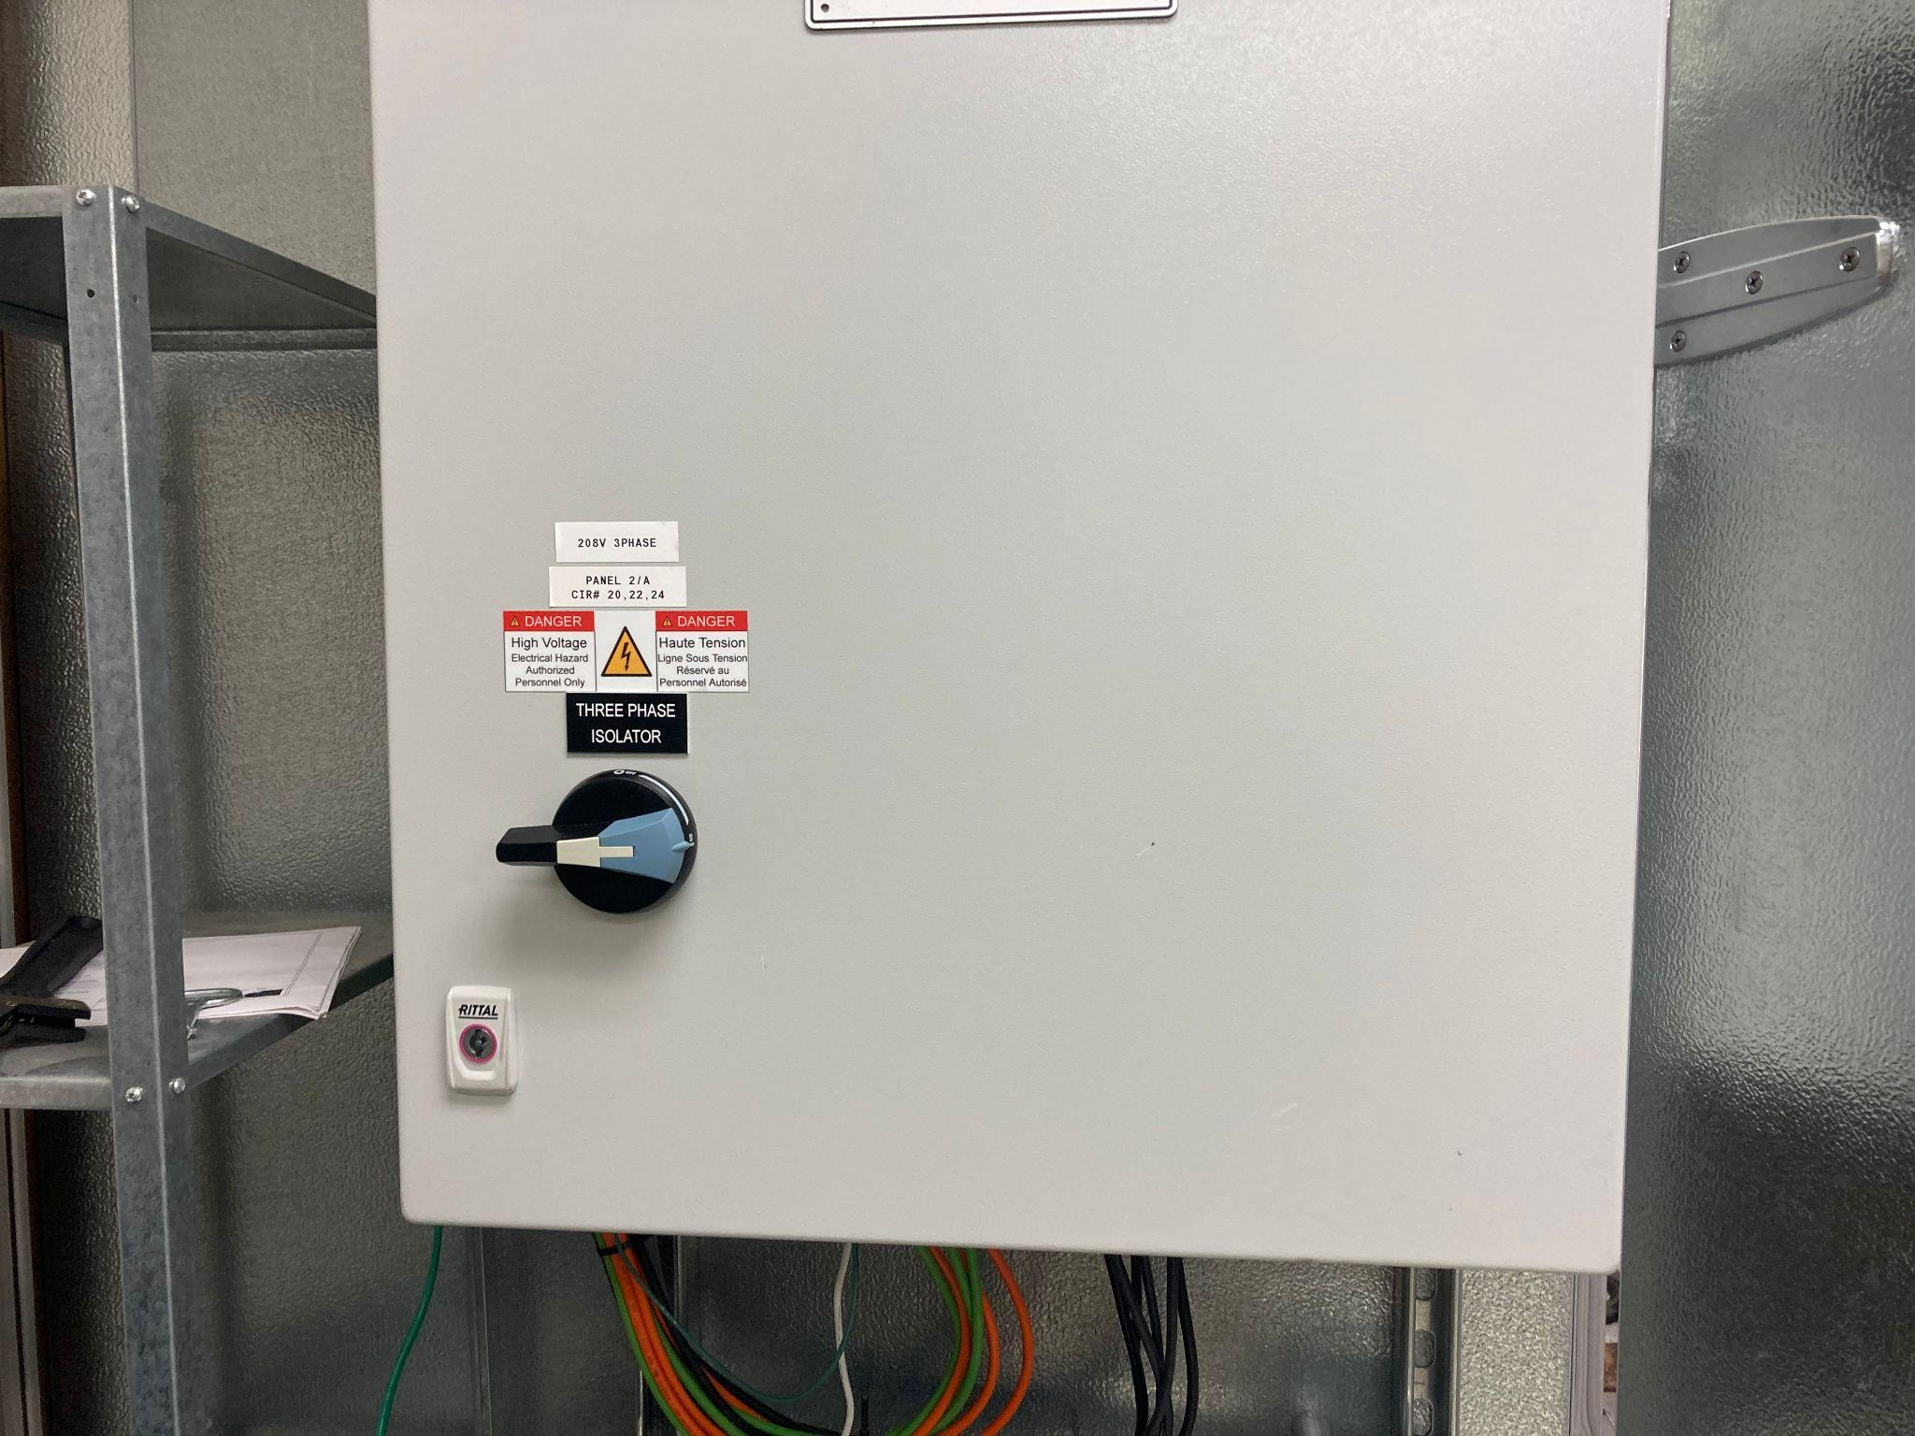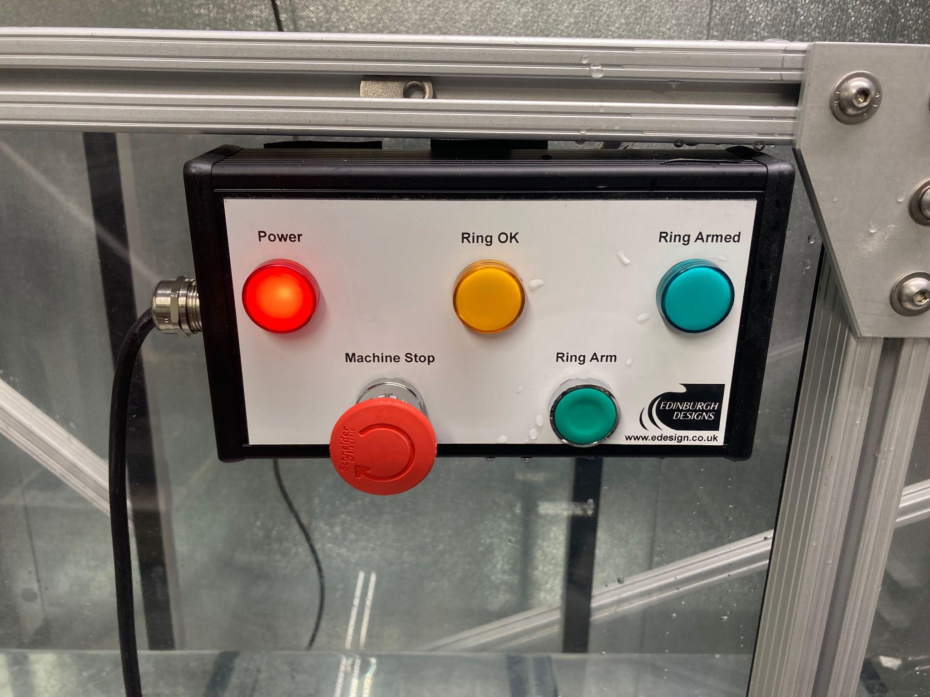

# SOFTWARE

On the desktop computer in Weeks 254, go to Start → All Apps → **Edinburgh Designs**. This folder contains the *engine* software (**Wisconsin Wavemaker Engine**) and the *client* software (**Njord Client**) needed to run the wavemaker, plus the software for designing more complicated wave experiments (**Njord Wave Synthesis**). The folder also houses manuals for additional software assistance – the **Wave Runtime Manual** is a PDF that helps the user navigate the Njord Client software (i.e. running the wavemaker itself), while the **Njord Manual** provides references for creating target wave runs in Njord Wave Synthesis (the files from which will be run in the Njord Client software).

## Wavemaker power up

Start by turning the power to the wavemaker on, by turning the “Three Phase Isolator” handle on the cabinet to the right (ON) position (left). The red Power button on the panel in the freezer (right) will be lit up and the wavemaker will be connected to the software.



From the Edinburgh Designs folder:

1. Start the *engine* software (open **Wisconsin Wavemaker Engine**), which connects to the PC and the wavemaker hardware itself
2. Start the *client* software (open **Njord Client**), which provides the graphical user interface that allows the user to have remote control of the wavemaker

The Njord Client interface will become the “Wisconsin Flume Tank Wavemaker” window, and the 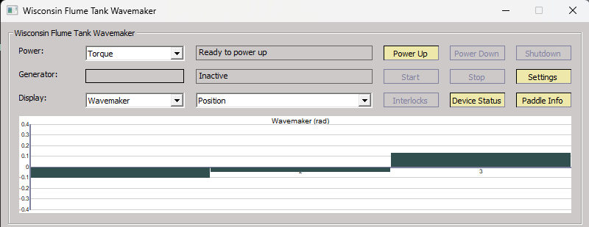machine should be “Ready to power up” with the Power Up button highlighted:

You can also check that the wavemaker is indeed on and connected in the Device Status (otherwise would not be ready to power up), i.e. that all three paddles are in the backward position (green) – their resting, powered down state – and not unattached (black):

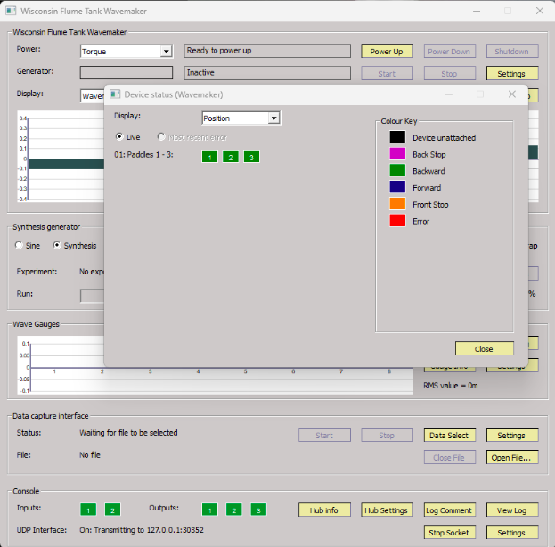

Click the Power Up button and follow the prompts:

1. First, it will check with you that the water depth (and any other specified parameters?) is correct, e.g. *h* = 0.4 m (default value?)
2. Next, it will prompt you to go into the freezer and press the green “Ring Arm” button
3. Then wavemaker will move through a calibration of the three paddles as they move up into their working position (vertical) and “running mode”
4. Ultimately, power control pop-up will read “Now all powered up”

## Making waves - **Sine** wave generator

You can generate simple, single-frequency sinusoidal waves directly in the Njord Client software itself. Specify the desired wave amplitude in meters, frequency in Hz, and run time in minutes/seconds with the +/- buttons; clicking Settings in that section will allow you to change step sizes if necessary (screenshot taken *while* machine was running):

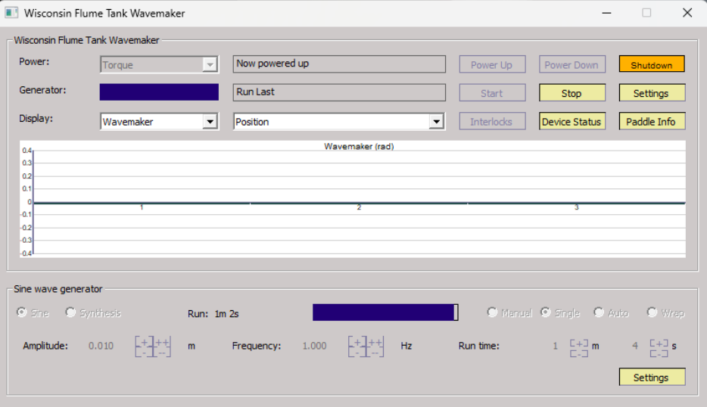

Change the run time for the waves from the default 64 seconds in *Single* playback mode (instead of *Manual*, which is just start-and-stop). Then simply click Start (second row of buttons from the top).

## Making waves - **Synthesis** wave generator

To generate more complicated waves in the tank – e.g. multiple frequencies, random phase shifts, and much more! – you will need to create a .experiment file of the desired wave(s) in **Njord Wave Synthesis** to then be opened/loaded into Njord Client. Note: all wave files should be saved to the **C:\edesign** folder for accessibility across programs.

From Start → All Apps → Edinburgh Designs folder, open **Njord Wave Synthesis**. The welcome screen will prompt you to open an existing .experiment file or create a new one starting with either a blank wave run or one from some pre-existing template:

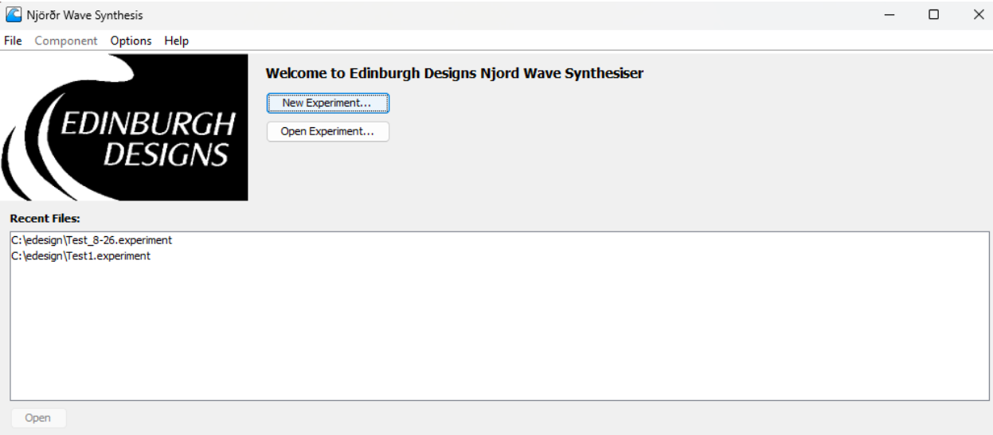

Make sure the configuration for the .experiment file is Torque (instead of Position), so it matches the power mode for the wavemaker shown near the top of the Njord Client window.

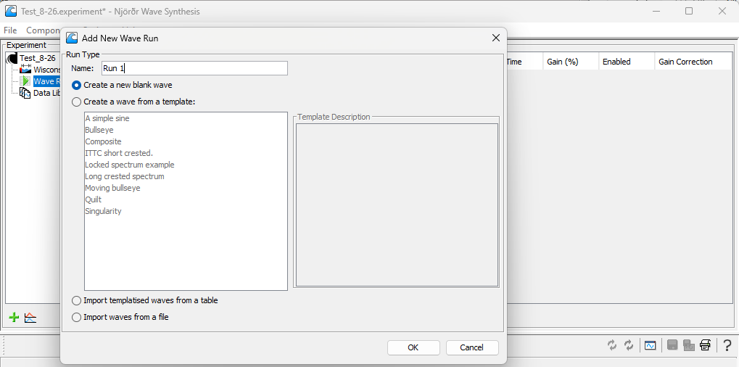

Each .experiment file contains at least one Wave Run, which corresponds to a certain duration of wave properties – basically one experimental *run*. A particular Wave Run can be made of one or more wave components that combine to produce the desired waveform that will run for a set amount of time.

To add a wave shape/component to a Wave Run, right-click on Wave Specification in the Wave Builder section of the window; the possible wave types to be used in a Wave Run include Sine, Spectrum, Fronts, etc. Selecting each component under the Wave Specification heading will allow you manipulate the properties of that wave component. If there is no default value for a parameter, the text will be highlighted in red, as will the tree of components leading up to it. As an example, in the screenshot below, two sine components with different frequencies and amplitudes (but same phase) have been added to Wave Run 1: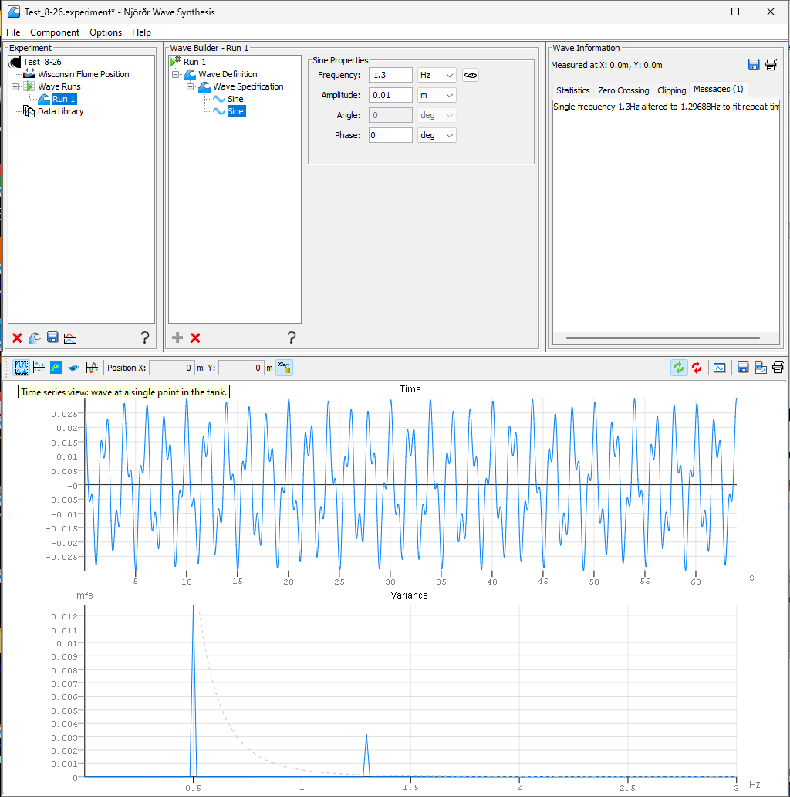



The lower half of the window is called the visualization pane, which is where you can observe the expected output of the Wave Run you are currently working on. The time series view (above) shows how the waveform will appear at a single position in the tank, which defaults to (0,0) (right at the wavemaker edge). On the note of wave *position*, in the Wave Specification for a particular Run, you can set the *x*-position and time for *where* in the tank the wave will be generated and *when* that will occur; the time here controls the *offset* from the start of the repeat time set in the Wave Definition section (default = 64 seconds). Note: the repeat time is independent of the actual experimental run time, so you’ll want to run the experiment and capture data for longer than 1 repeat time, then analyze it for an integer number of repeat times.

The wavemaker has multiple means of protecting itself, preventing you from trying to send it a wave it cannot generate. For example, if you specify too large of a wave amplitude such that the angle the paddles must move through is beyond their range of motion, the waveform will be subject to clipping (see following two screenshots). There is a clipping view in the visualization pane to check the feasibility of the designed wave; plus, if a wave you are making starts clipping, the upper half view will automatically switch to Clipping in the Wave Information section to get your attention.

Wave Run getting clipped – not good!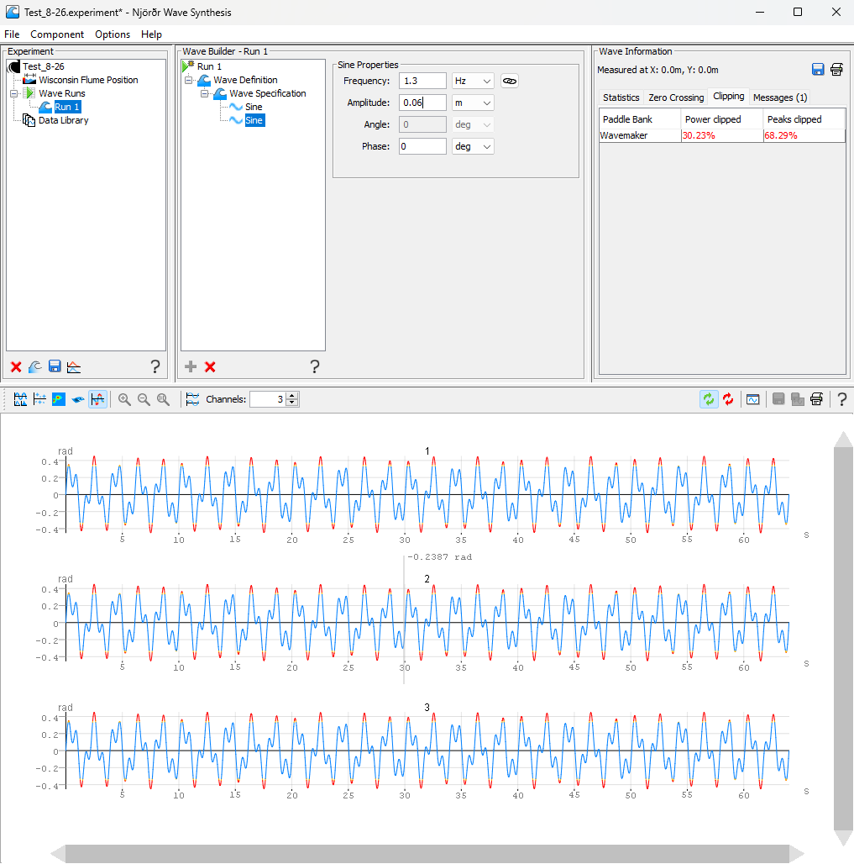

Wave Run not causing clipping (decreased sine component amplitude) – all good!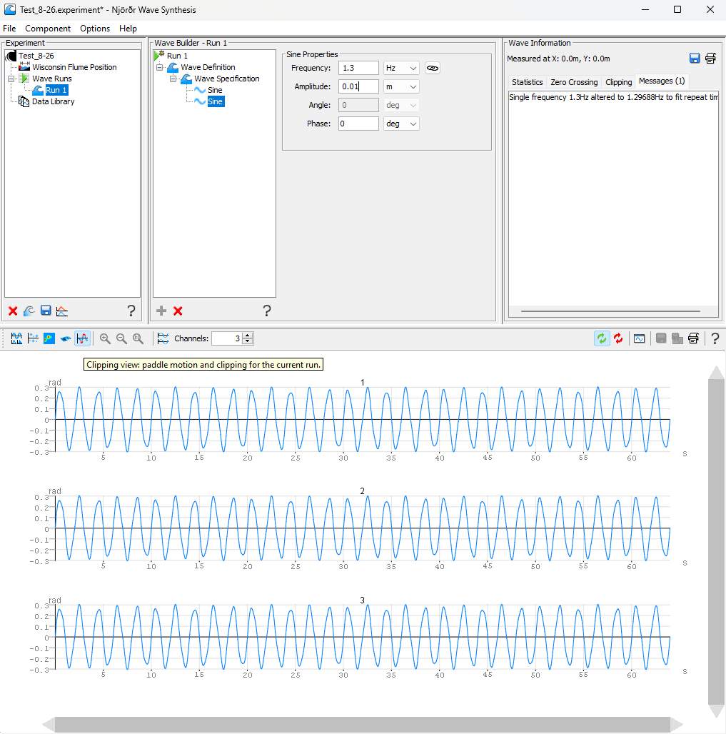

Once your file of wave runs has been constructed and saved in **Njord Wave Synthesis**, head back to the **Njord Client** software (Wisconsin Flume Tank Wavemaker window) and Open the .experiment file under the Synthesis generator heading. The playback modes include: Single to do a single Wave Run from the file; or Auto to execute all Wave Runs sequentially with a default wait time of 20 seconds between each. For example, Test_8-26.experiment contains 3 runs: Run 1 (two sine waves) runs for 64 seconds, then the wavemaker stops and waits 20 seconds; Run 2 (PM spectrum with random phase shift) runs for 64 seconds, wavemaker stops and waits another 20 seconds; lastly, Run 3 (just a 2.5 Hz sine wave) for 25 seconds.

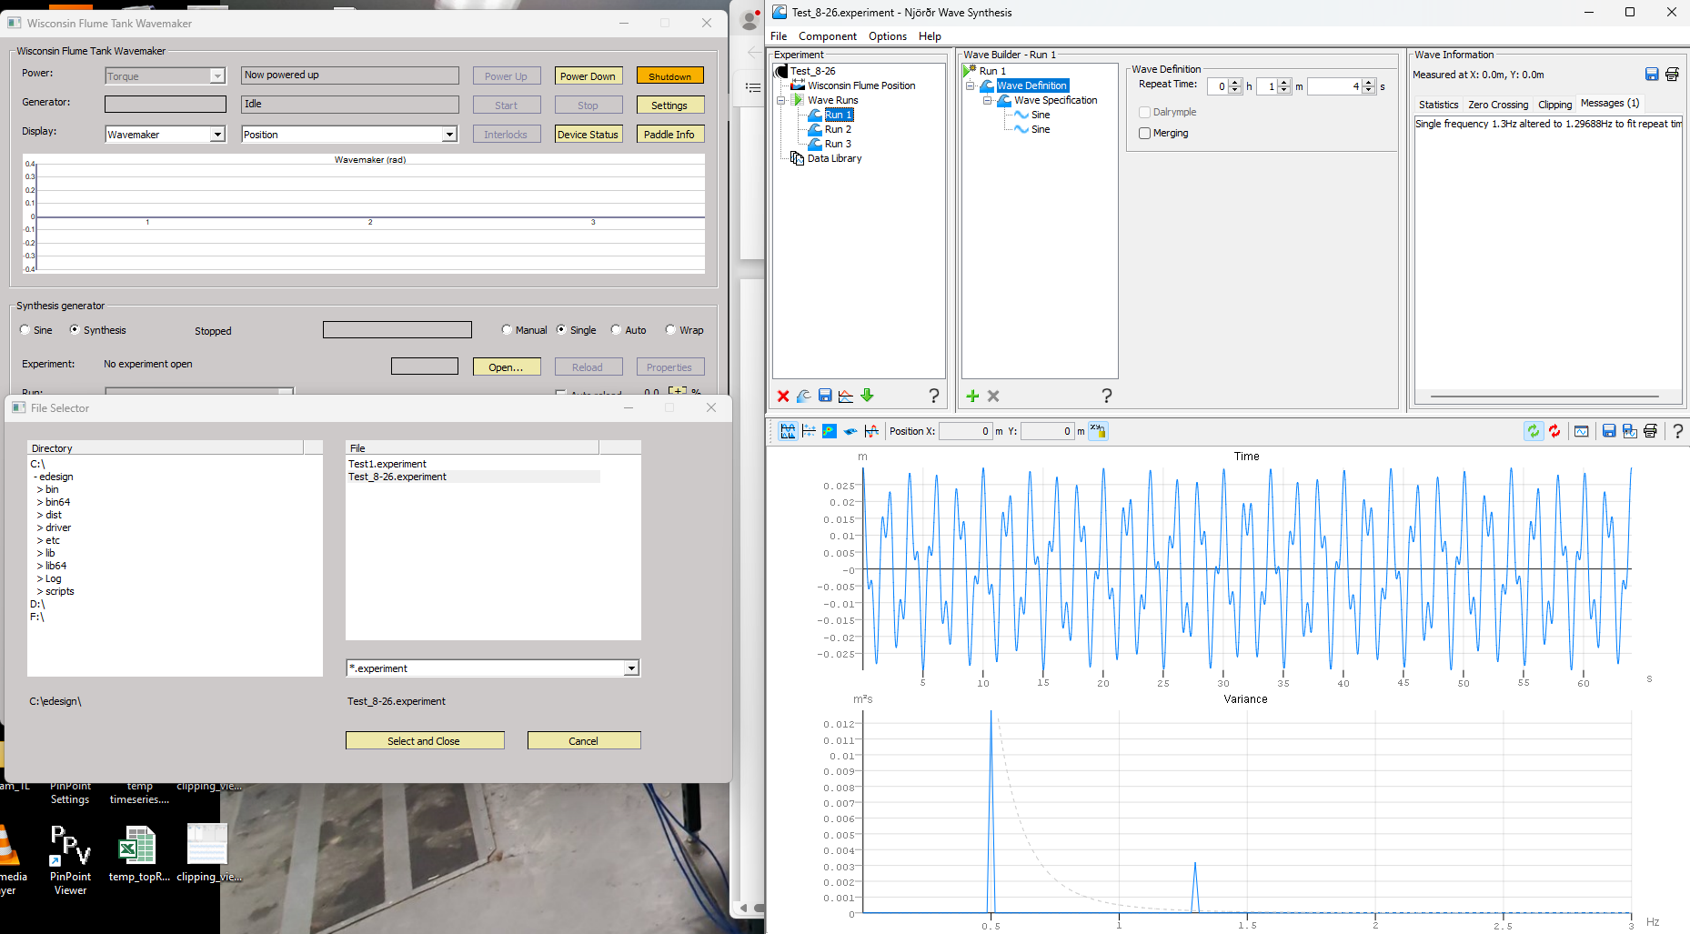

## Wavemaker power down

Once the waves are done being generated and the machine is back in its working position (paddles vertical), click the Power Down button in the Njord Client window (right next to the Power Up button) and follow any prompts. The paddles will return to their back stops, the motor drive will power off, and the machine will be back in “ready to power up” mode. Turn the “Three Phase Isolator” handle on the exterior cabinet to OFF.

## Wavemaker start/stop

This piece of software has the ability to generate monochromatic waves without additional programming, however it is really designed to orchestrate wavemaker programs generated by the other piece of software.

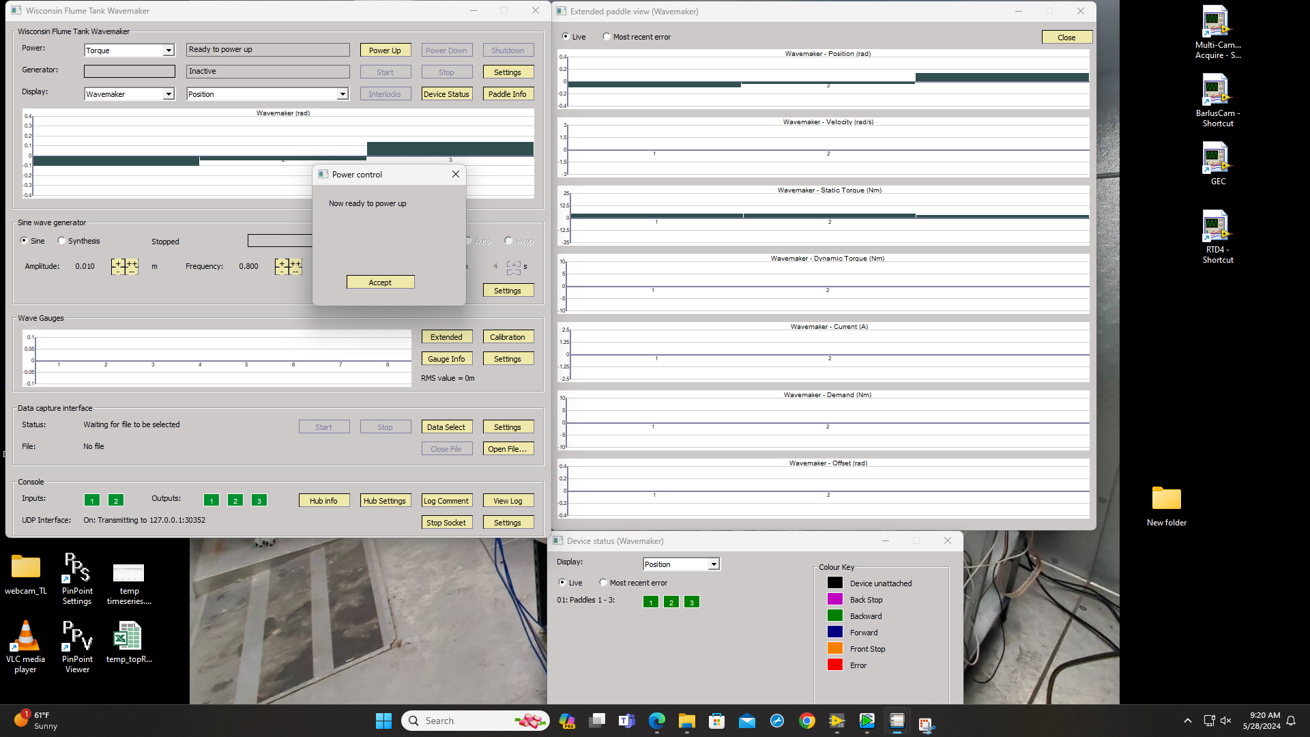

## Wavemaker program generation

Starting a new experiment file.

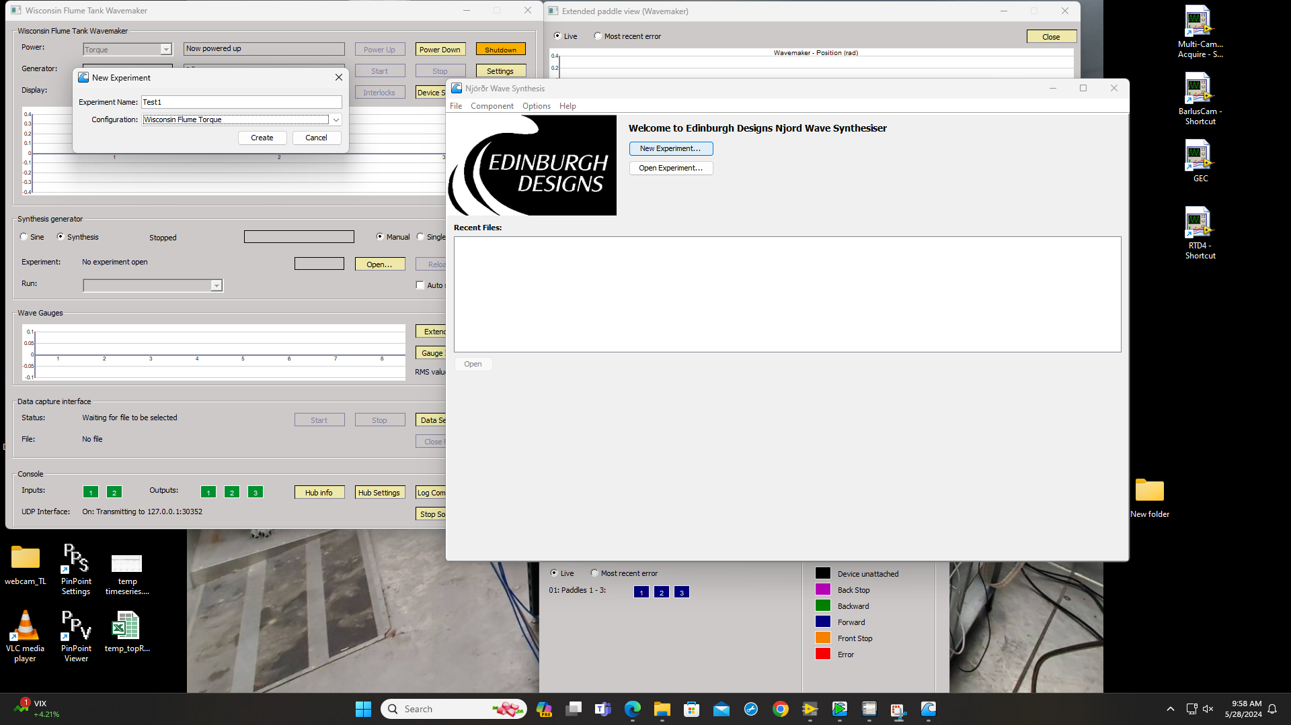

Detailed steps to generate a run, TBD

## 

## Spectra definitions

Spectra can be verified, and custom ones can be created, from the options menu.

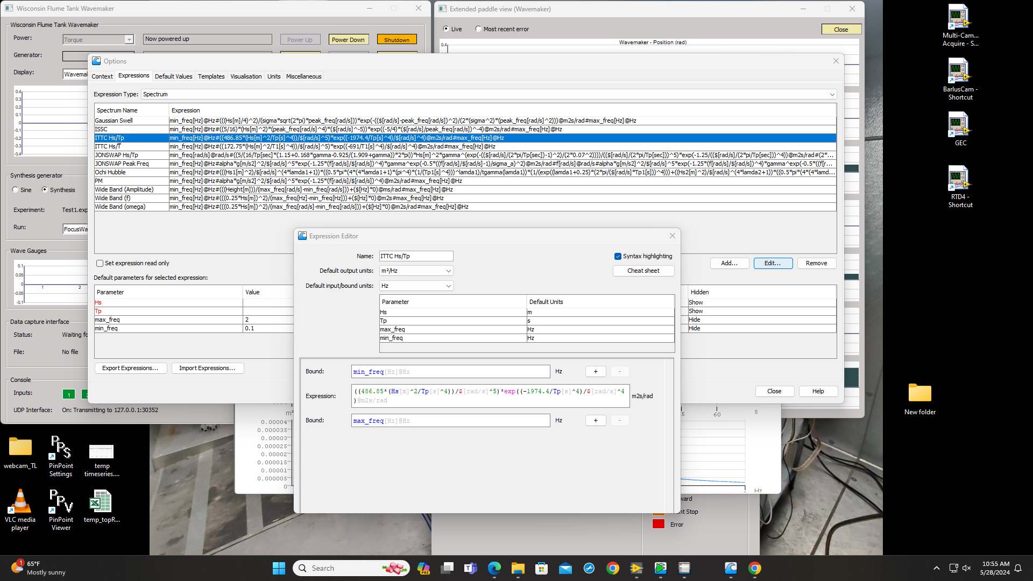

## Getting more help

# 

# Performance testing and validation